Assignment:- 9
Case-Study
Digital Electronics & Microprocessor Applications in Modern Automotive Systems (Smart Cars)

Introduction:
The automotive industry has undergone a massive transformation with the integration of digital electronics and microprocessors. Modern vehicles are no longer purely mechanical devices — they are intelligent, computer-controlled machines capable of making decisions, monitoring real-time conditions, enhancing safety, and optimizing engine performance.
Digital circuits, microprocessors, memory units, sensors, interrupts, and timers all work together inside an automobile to create systems such as ABS (Anti-lock Braking System), Airbags, Engine Control Units (ECU), Cruise Control, Parking Assist, Climate Control, and Infotainment Systems.
This case study explores how concepts from digital fundamentals and microprocessor architecture are seamlessly woven into the design and functioning of smart automotive systems.

System Overview:
A modern car contains anywhere between 50–150 Electronic Control Units (ECUs). Each ECU is a microprocessor-based embedded controller responsible for a specific function. These ECUs communicate through CAN, LIN, or FlexRay communication buses.
A simplified system includes:
- Sensors: Speed sensors, temperature sensors, oxygen sensors, pressure sensors, proximity sensors.
- Digital Logic Circuits: Decision-making for simple ON/OFF operations.
- Microprocessors/Microcontrollers: Execute engine control algorithms.
- Communication Bus: Connects ECUs.
- Actuators: Fuel injectors, brake controllers, steering actuators.
- User Interface: Dashboard display, buttons, warning lights.

Role of Digital Logic in Automotive Electronics:
Digital fundamentals play a huge role in the processing of signals within the car. Sensor data is often converted into binary, BCD, or Gray code for efficient digital processing.

Examples:
- Wheel speed sensors in ABS generate signals converted into Gray code to avoid errors during rapid transitions.
- Fuel level indicators use ADC + digital logic to determine low fuel warning.
- Airbag system uses fast, simplified logic circuits to detect impact and trigger inflation.
Boolean logic is used extensively:
Example logic:
- If speed > threshold AND brake applied → activate ABS controller.
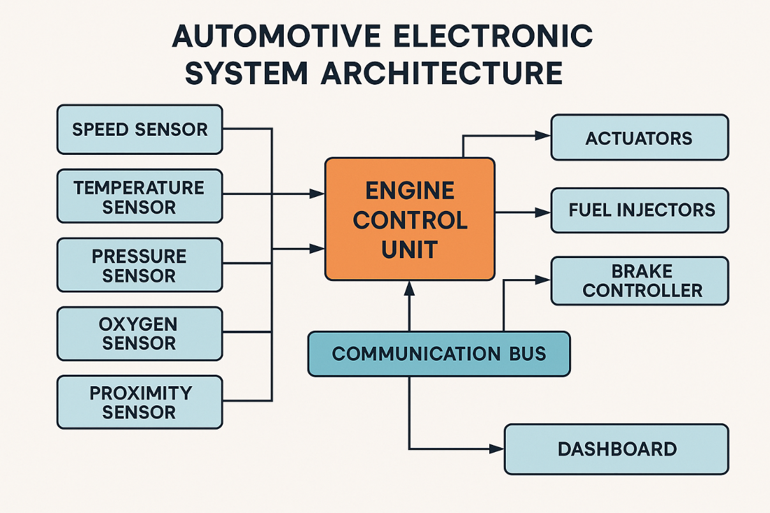

Combinational Circuits Inside Vehicles:
Many automotive subsystems use combinational logic:
- Adders/Subtractors:
Used in the ECU to calculate acceleration, control fuel injection, and determine engine load.
- Multiplexers (MUX):
Select signals from multiple sensors (e.g., selecting temperature sensor input based on region of engine).
- Demultiplexers:
Distribute processed signals to different actuators.
- Encoders and Decoders:
Used in keyless entry systems and communication between ECUs.
- Parity Checkers:
Ensure error-free data transmission between modules — critical in safety systems like airbags.

Sequential Circuits in Automotive Systems:
Sequential circuits store information and maintain the vehicle’s operational states:
Flip-Flops (SR, JK, D, T)
- Used as memory elements inside airbag modules.
- Store seatbelt status, ignition status, brake pedal status.
- JK flip-flops act as control latches in gear-shift logic.

Counters
- Speedometers use frequency counters to calculate vehicle speed.
- Timers in indicator blinkers use counters to generate timed pulses.
- Engine control timing depends on counters synchronized with crankshaft rotation.

State Machines
Sequential logic creates the finite state machines used in:

- Cruise control
- Automatic gearboxes
- Electronic power steering

Role of Interrupts and Timers:
Interrupt examples:
- Wheel slip interrupt → triggers ABS.
- Airbag crash detection → highest priority interrupt.
- Engine knock interrupt → retune ignition timing.
- Temperature warning → activate fan.

8259-like interrupt priority control:
Similar concepts are used to decide:
- Airbag > ABS > Engine Overheat > Low Battery

Real-Life Impact and Benefits:
- Improved safety (ABS, airbags)
- Fuel efficiency (optimized engine control)
- Comfort (automatic climate control)
- Convenience (keyless entry, parking assist)
- Reduced emissions (precise combustion control)
- Autonomous driving foundation (sensors + microprocessors + digital logic)
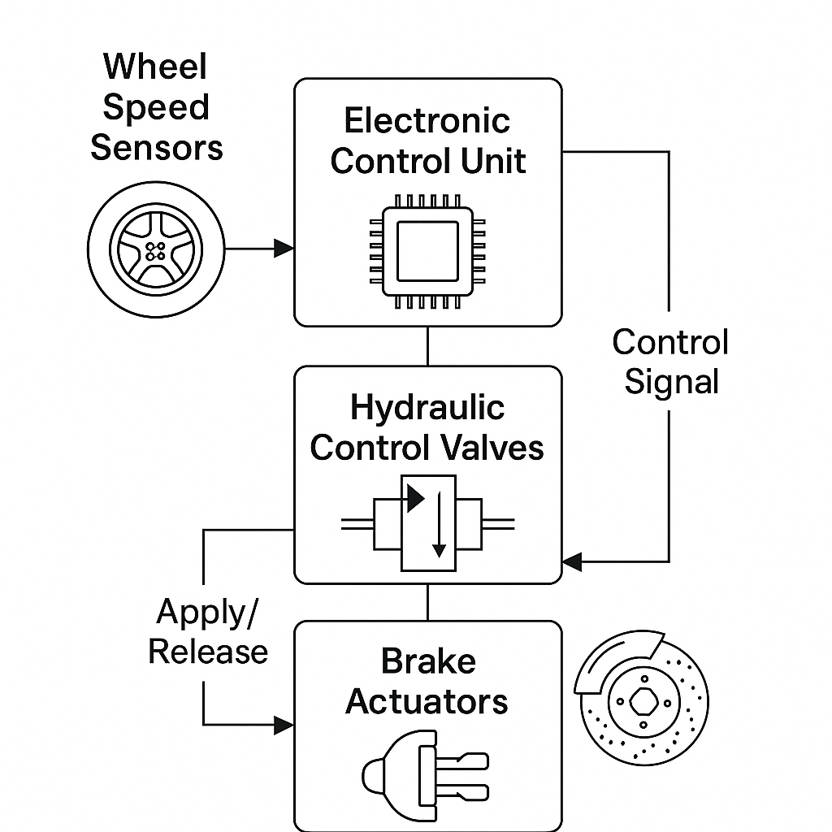




Conclusion:
Modern cars are the perfect example of how digital fundamentals, combinational circuits, sequential logic, microprocessors, interrupts, and timers are combined to create intelligent electronic systems.
From the smallest logic gate to the most advanced superscalar CPU, every concept learned in digital electronics plays a role in the automotive ecosystem.

This case study demonstrates how syllabus concepts directly translate into real-world applications, powering the future of smart transportation.

